Prepare workbooks for collaboration.

Restrict Editing
- Restrict editing to ensure only specific users or groups can modify the workbook.
  - Steps to Restrict Editing:
    - Go to File > Info.
    - Click Protect Workbook > Restrict Editing.
    - Set permissions for who can edit the workbook by specifying users.

Protect Worksheets and Cell Ranges
- Use this feature to prevent unauthorized changes to specific sheets or cell ranges.
  - Protect a Worksheet:
    - Go to the worksheet you want to protect.
    - Navigate to Review > Protect Sheet.
    - Set a password (optional) and choose what actions users are allowed to perform (e.g., select cells, format rows).
  - Protect Specific Ranges:
    - Select the cells or range you want to lock.
    - Right-click and choose Format Cells > Protection.
    - Check the Locked option.
    - Protect the worksheet using Review > Protect Sheet.

Protect Workbook Structure
- Protect the workbook structure to prevent actions like adding, deleting, hiding, or renaming sheets.
  - Steps to Protect Workbook Structure:
    - Go to Review > Protect Workbook.
    - Check the option Structure.
    - Set a password (optional) to ensure only authorized users can modify the structure.

Configure Formula Calculation Options
- Adjusting formula calculation settings ensures workbook performance and accuracy during collaboration.
  - Options Available:
    - Automatic: Formulas recalculate whenever a change is made.
    - Manual: Formulas only recalculate when triggered by pressing F9.
    - Steps to Configure:
      - Go to File > Options > Formulas.
      - Choose the calculation mode (Automatic or Manual).
      - Enable or disable options like recalculating for data tables or updating external references.
  - Manual calculation is helpful in large, complex workbooks to improve performance.

Manage Comments
- Comments are useful for collaboration, as they allow users to leave feedback or notes on specific cells.
  - Add Comments:
    - Right-click on a cell and select New Comment.
    - Type your feedback or instructions in the comment box.
  - Edit/Delete Comments:
    - Right-click the commented cell and select Edit Comment or Delete Comment.
  - Threaded Comments (modern Excel):
    - Allows a conversation-like feature where users can reply to existing comments.
  - Managing All Comments:
Use Review > Show Comments to view or navigate all comments in the workbook.

Use Language-Specific Features
Excel supports features tailored to specific languages, such as:
- Right-to-Left Languages (e.g., Arabic, Hebrew):
  - Enables text and worksheet alignment for right-to-left scripts.
  - To enable, configure the editing language (as explained above) and go to the View tab to change the sheet direction.
- Proofing Tools:
  - Spell check and grammar check are available in the editing language.
  - To access proofing:
    - Go to Review > Spelling & Grammar.
    - Ensure proofing tools for the selected language are installed.
- Date and Number Formats:
  - Excel adapts number, date, and currency formatting to the chosen editing language.
  - To customize:
    - Right-click on a cell and choose Format Cells > Number.
    - Select the appropriate locale under the Locale (location) drop-down.
- Translation Features:
  - Translate content between languages directly within Excel:
    - Go to Review > Translate.
    - Select the source and target languages.
Fill cells based on existing data

Fill Cells by Using Flash Fill
- Flash Fill is a feature that automatically fills data in a column based on a pattern you establish using existing data.
- It's useful for tasks like extracting first names, combining text, or reformatting data.
Steps to Use Flash Fill:
- Enter an example of the desired result in a cell adjacent to your data (e.g., type the first name extracted from "John Doe").
- Move to the next cell and press Ctrl + E (or go to Data > Flash Fill).
- Excel will detect the pattern and fill the remaining cells.
Example Use Cases:
- Extracting First or Last Names:
Input: "John Doe"
Output: "John" (Flash Fill will extract the first names for the rest of the column).
- Formatting Phone Numbers:
Input: 1234567890 → (123) 456-7890.
- Combining Data:
Input: Columns with First Name and Last Name → Combine into "FirstName LastName."
Tips:
- Flash Fill works best when the pattern is clear and consistent.
- If Flash Fill doesn’t trigger, ensure the feature is enabled under File > Options > Advanced > Editing Options > Automatically Flash Fill.

Fill Cells by Using Advanced Fill Series Options
- Fill Series allows you to create a sequence or pattern of numbers, dates, or other data automatically.
Steps to Use Fill Series:
- Select the starting cell with the initial value of your series.
- Drag the fill handle (a small square in the bottom-right corner of the cell) to extend the series.
- Hold Ctrl (if needed) to enforce a series instead of repeating the initial value.
For Advanced Options:
- Go to Home > Fill > Series.
- Choose options in the Series Dialog Box:
  - Series in: Choose whether to fill across rows or down columns.
  - Type:
    - Linear: Creates a numeric sequence (e.g., 1, 2, 3...).
    - Growth: Multiplies values by a factor (e.g., 2, 4, 8...).
    - Date: Creates a series of dates.
    - AutoFill: Detects patterns automatically.
  - Step Value: Sets the increment (e.g., 2 to create 2, 4, 6...).
  - Stop Value: Defines the endpoint of the series.
Example Use Cases:
- Numeric Sequences: Start with 1, set a step value of 2 → Generates 1, 3, 5...
- Date Sequences: Start with 01/01/2025, choose a step value of 7 → Generates weekly dates.
- Custom Patterns: Use AutoFill to extend non-numeric patterns (e.g., Mon, Tue, Wed...).
Tips:
- For non-standard patterns (e.g., Q1, Q2, Q3), type the first few values to establish the sequence before dragging the fill handle.
- If Excel fills values incorrectly, check the series type in the dialog box.

Format and validate data

Data Validation
- Data Validation gives you the control to receive particular inputs from users. Data Validation gives you the control to receive particular inputs from users.
How to do Data Validation in Excel
The data validation function can be found in the DATA tab from the Excel ribbon(as seen in the picture below).
Step 1: Click on the Data Tab in the Ribbon.
Step 2: Now select Data Validation.
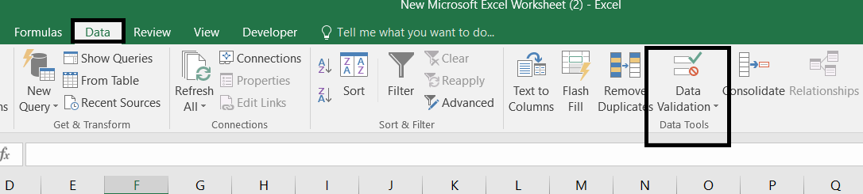
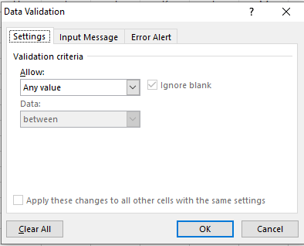
There are 3 tabs in the dialogue box.
- Settings: This will help you to select the data type and the type of data that you want to be filled in the desired row or column.
- Input Message: This tab will help to let the user know about the constraints you’ve decided on for the row/column. It will alert the user to input the right set of values.
- Error Alert: The error alert tab will help the user to know that they had entered invalid data.

Excel Data Validation List
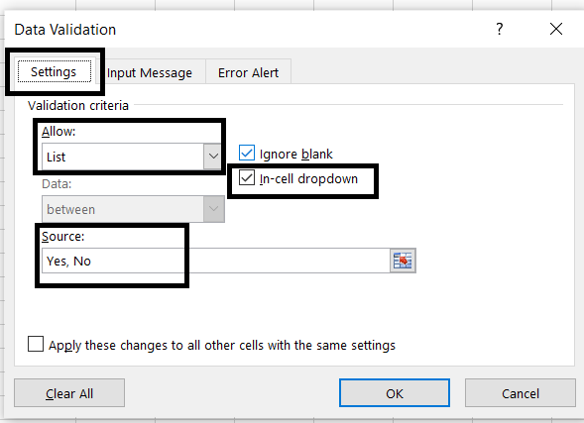
Group and Ungroup with Subtotals
Worksheets with a lot of content can sometimes feel overwhelming and can even become difficult to read. Fortunately, Excel can organize data into groups, allowing you to easily show and hide different sections of your worksheet. You can also summarize different groups using the Subtotal command and create an outline for your worksheet.
To group rows or columns:
Select the rows or columns you want to group. In this example, we'll select columns B, C, and D.
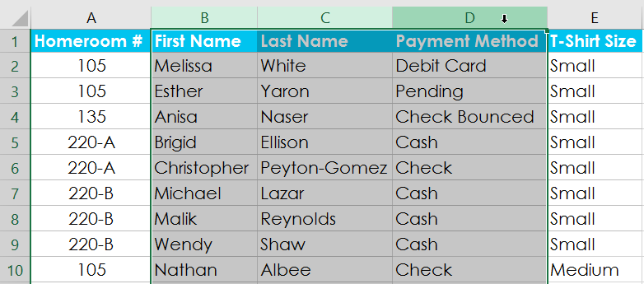
Select the Data tab on the Ribbon, then click the Group command.
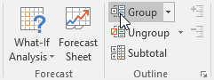
The selected rows or columns will be grouped. In our example, columns B, C, and D are grouped.
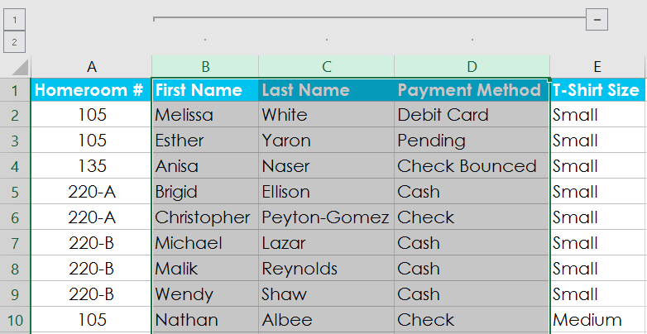
To ungroup data, select the grouped rows or columns, then click the Ungroup command.

Find and remove duplicates
- Select the cells you want to check for duplicates.
- Select Home > Conditional Formatting > Highlight Cells Rules > Duplicate Values.
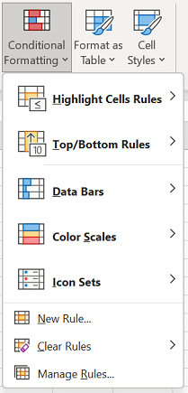
- In the box next to values with, pick the formatting you want to apply to the duplicate values, and then select OK.
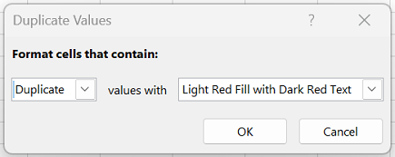
Remove duplicate values
When you use the Remove Duplicates feature, the duplicate data is permanently deleted. Before you delete the duplicates, it’s a good idea to copy the original data to another worksheet so you don’t accidentally lose any information.
- Select the range of cells that has duplicate values you want to remove.
Tip: Remove any outlines or subtotals from your data before trying to remove duplicates.
- Select Data > Remove Duplicates, and then under Columns, check or uncheck the columns where you want to remove the duplicates.
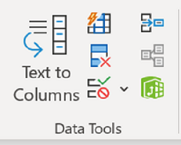
For example, in this worksheet, the January column has price information that needs to be kept.
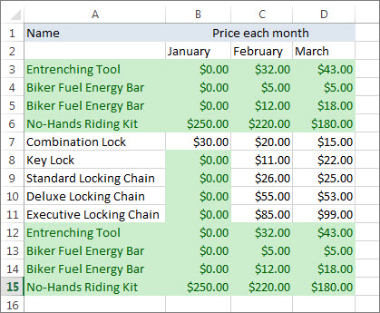
To do so, uncheck January in the Remove Duplicates box.
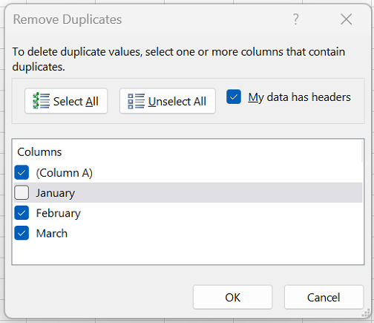
- Select OK.

Conditional Formatting
Conditional formatting is used to change the appearance of cells in a range based on your specified conditions.
The conditions are rules based on specified numerical values or matching text.
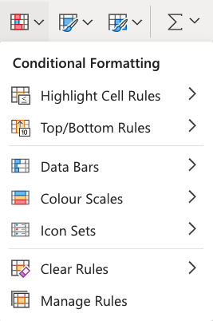
There are various conditions that can be tested in order to apply the formatting:
- Format cells based on their values
- Format cells that contain a certain text
- Format top/bottom-ranked cells in a range
- Format duplicates
- Format cells based on a formula

Formatting cells based on their values - example
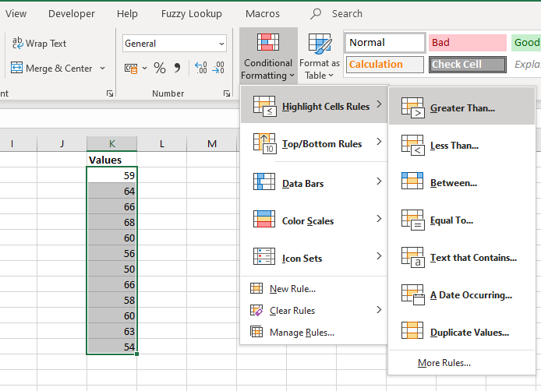
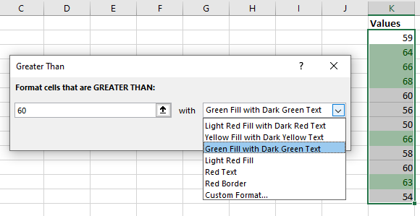

Advanced Filter
Advanced Filter allows us to quickly filter based on several criteria that are predefined in a separate table.

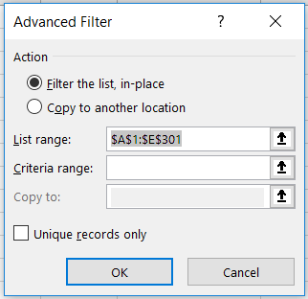
Advantages of Advanced Filter over “normal” filter:
- No need to choose each item we want to filter (imagine wanting to filter for 100 values out of 1,000), we can create a table instead.
- Allows us to filter based on several columns at once, using “AND” & “OR” operators.
  - AND – all conditions have to be met
  - OR – At least one condition has to be met

Advanced Filter example
In the table below, we would like to filter for people who live in London, Manchester, Glasgow or Cardiff:
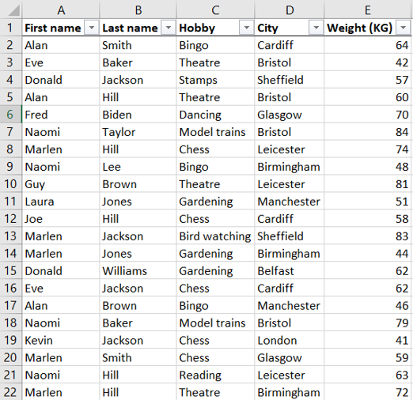
Of course, you can manually tick the 4 cities, but what if you had to filter for 50 cities?
Let’s use Advanced Filter to do this!
First step – We will create a table with one column, where we will list the cities for which we wish to filter. Above that list we will put a header.
Important: For Advanced Filter to work, we have to give our new column the same header as in the table we are filtering, for our example that will be “City”:
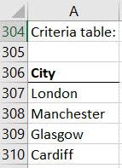
Second step – We will go the the “Data” ribbon and click on “Advanced”
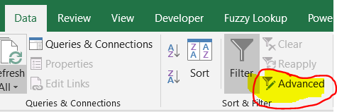
Third step – We will now select the ranges for our list range (the range we want to filter) and criteria range (the table we created in the first step):
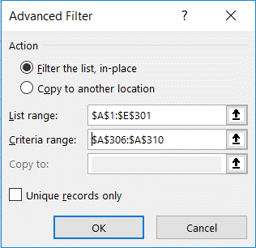
Success! Your table should now look like this:

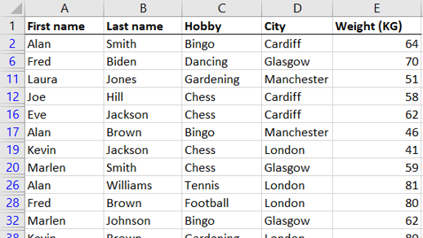
To un-filter, simply click on “Clear” in the “Data” Ribbon.

Filtering using AND logic:
This filter is useful when we want all the criteria to be met, for example:
We want to find all the people who are named Alan and like chess. How will we do this?
Answer: we’ll create a table that uses “AND” by putting all the criteria values in the same row.
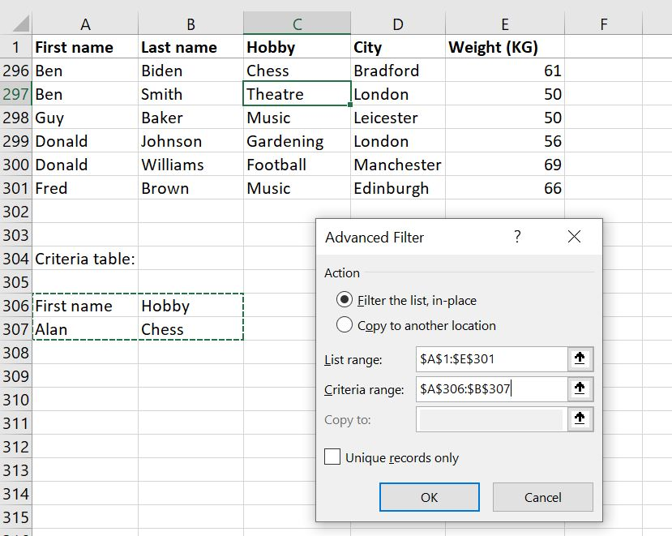
We asked the Advanced Filter to show us all the people who are named Alan AND like Chess. We did that by putting all the criteria in one row and using headers that match the original table.
And here’s the final result:
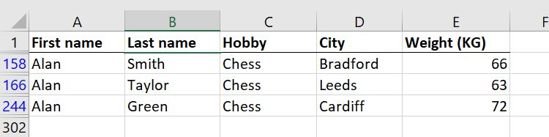

Filtering using OR logic:
This filter is useful when we want at least one of the criteria to be met, for example:
We want to find all the people who are either named Laura OR live in Leicester. How will we do this?
Answer: we’ll create a table that uses “OR” by putting all the criteria values in separate rows:
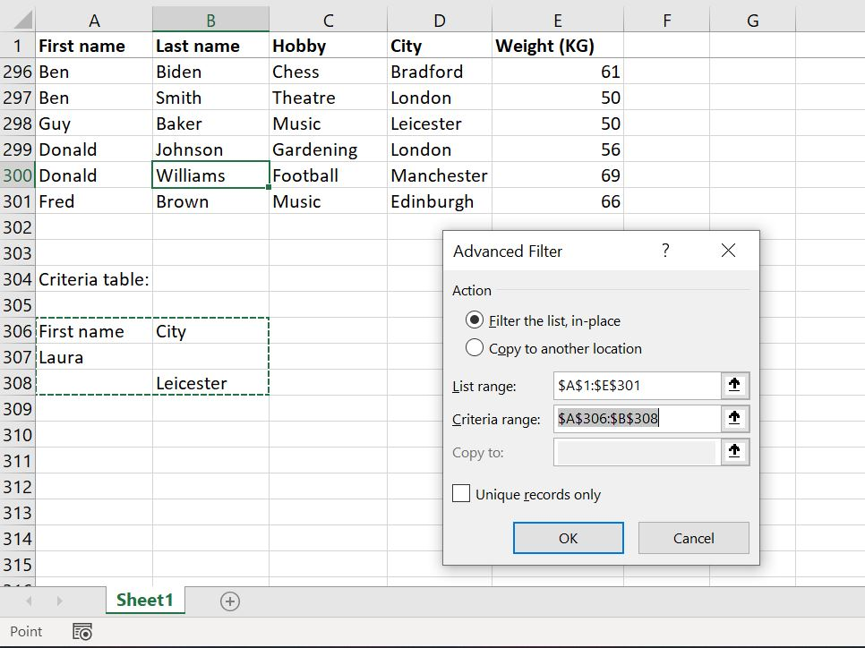
We asked the advanced Filter to show us all the people who are either named Laura OR live in Leicester (or both!). We did that by putting all the criteria in separate rows and using headers that match the original table.
Here’s the result:

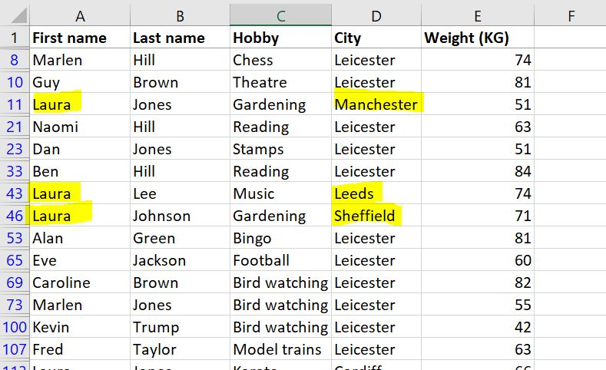

Filtering numerical values using Advanced Filter
We can use Advanced Filter when we want to filter for all numerical values which are larger/smaller than a specific value.
We would follow the same steps as in previous examples, except in the criteria we will add “<“ or “>”.
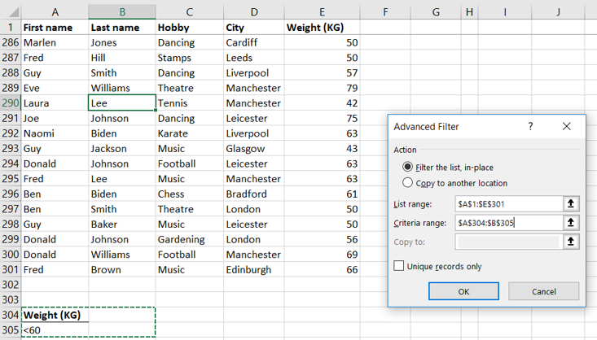
And the result will be:
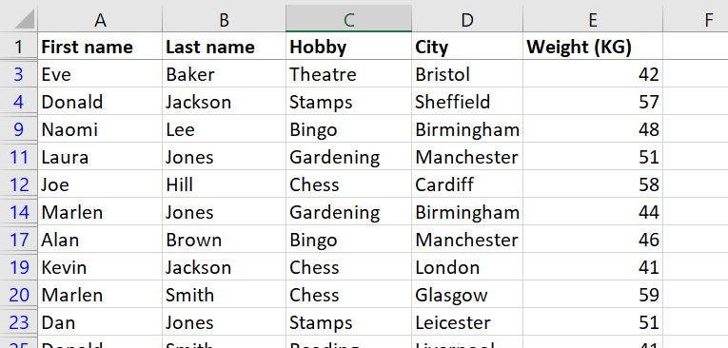
Tip – You can also use these operators:
<> – Does not equal to…
>= – Equals to or larger than…
<= – Equals to or smaller than…
Using wildcards in Advanced Filter
We can use the “?” and “*” wildcards combined with Advanced Filter to do magics!
The ? (Question mark) wildcard
When we use “?” wildcard, Excel knows we want it to guess ONE character.
For example, if we look for the first name “B?n”, it will return a list filtered for first names that have the sequence b?n within them:
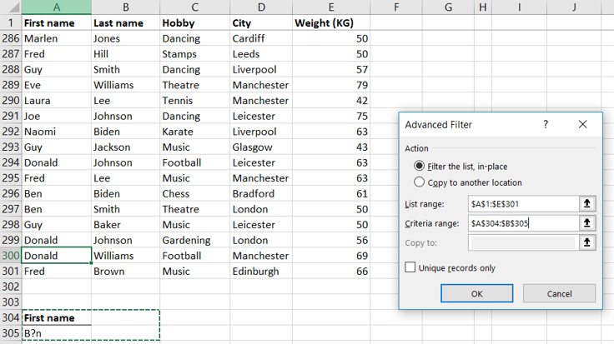
The result will be:
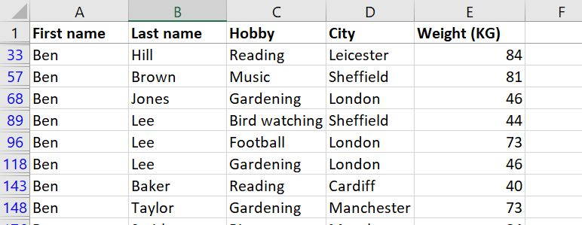

The * (Asterisk) wildcard
When we use “*”, Excel understands that we want it to guess an unknown number of characters – Anything between zero or more characters.
For example, if we look for the First Name “D*d” it will return a list filtered for first names that have the sequence “D*d” in them:
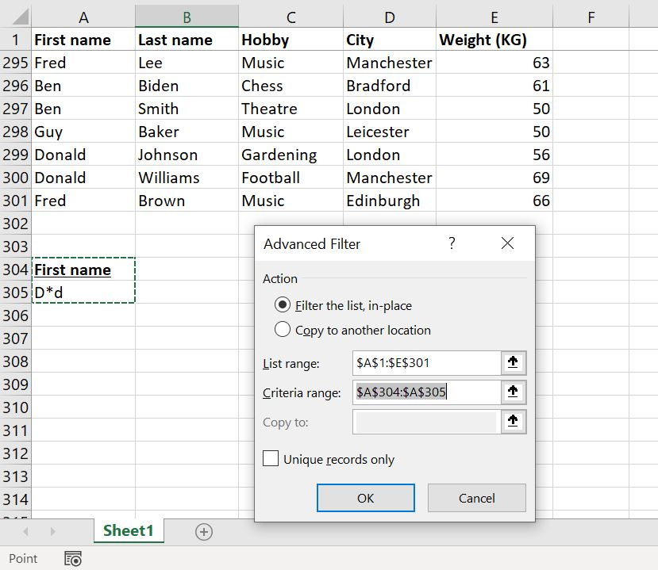
And the result:
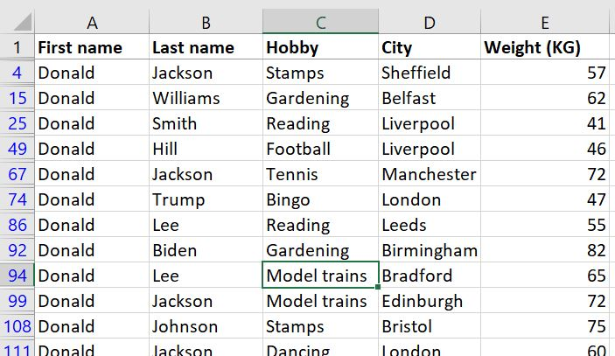

Creating a new table from the filtered range
We learned how to filter a table, but what if we want to create a new table from the filtered data?
Simply click “Copy to another location” and mention where you want to have the new table in the “Copy to” field:
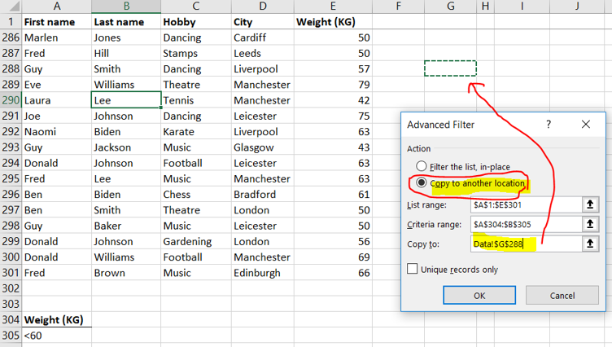
Warning – When you copy the filtered list to another location, you can’t undo (ctrl+z)

Functions
IF
Use IF function to check whether a certain condition (or conditions) is met.
If the condition is met, the function will return a predefined result.
If the condition is not met, the function will return a different predefined result.
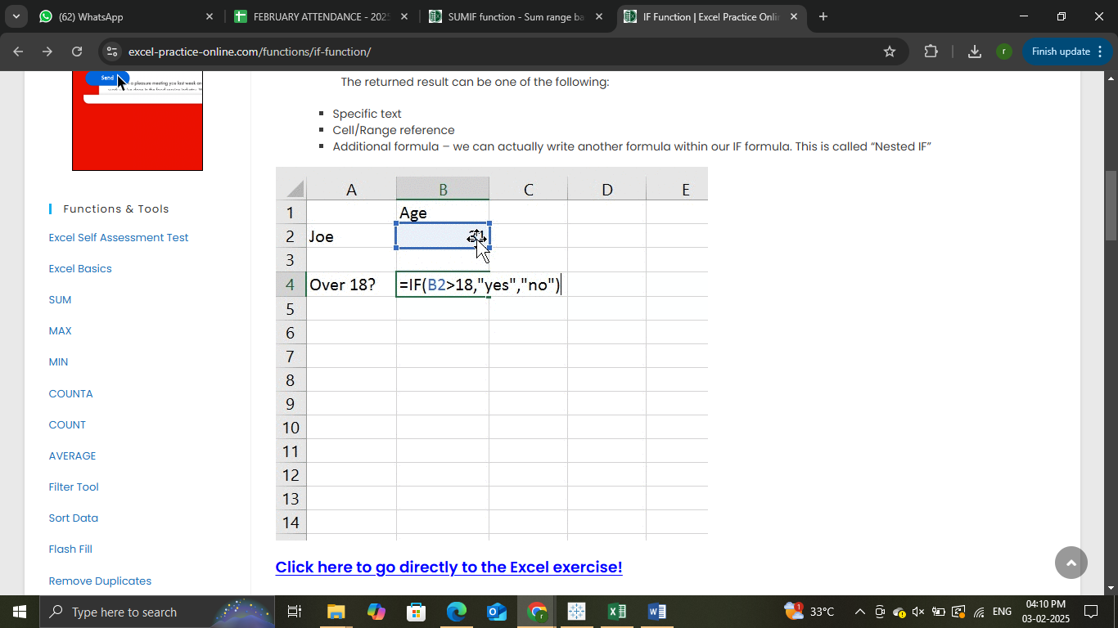

Nested IF
It is a combination of more than one IF function which can help us check multiple conditions.
IF function recap: IF function returns one value if a statement is TRUE, and another value if a statement is FALSE.
When we add one IF function within another IF function we create a Nested IF.

AND / OR
AND/OR functions allow the user to check if multiple criteria are met. They are extremely useful when combined with the IF function.
The AND function is used for checking if all criteria are met
The OR function is used for checking if at least one criterion is met.
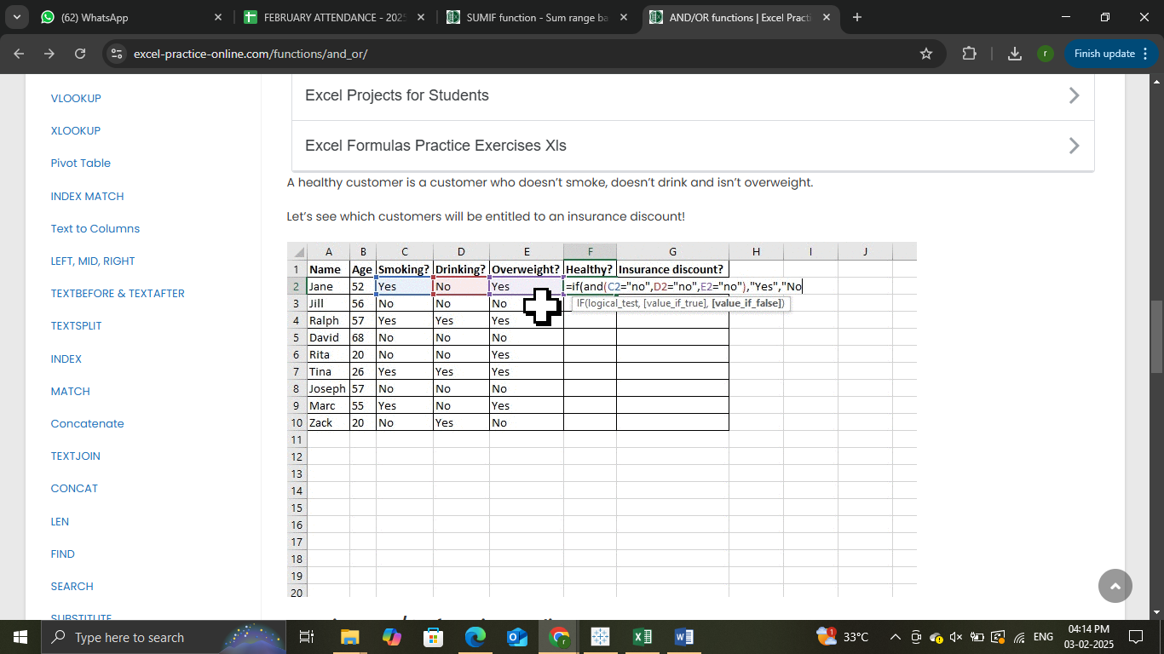

SWITCH
The Excel SWITCH function compares one value against a list of values, and returns a result corresponding to the first match found. When no match is found, SWITCH can return an optional default value.
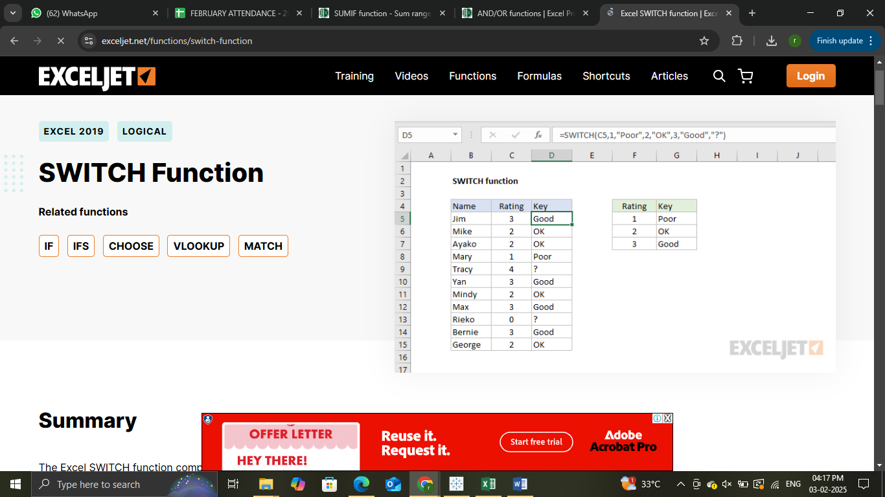

SUMIF
SUMIF function lets us sum a range based on a certain criteria. We can use this function to either sum a range based on a criteria within the same range, or within a different range.
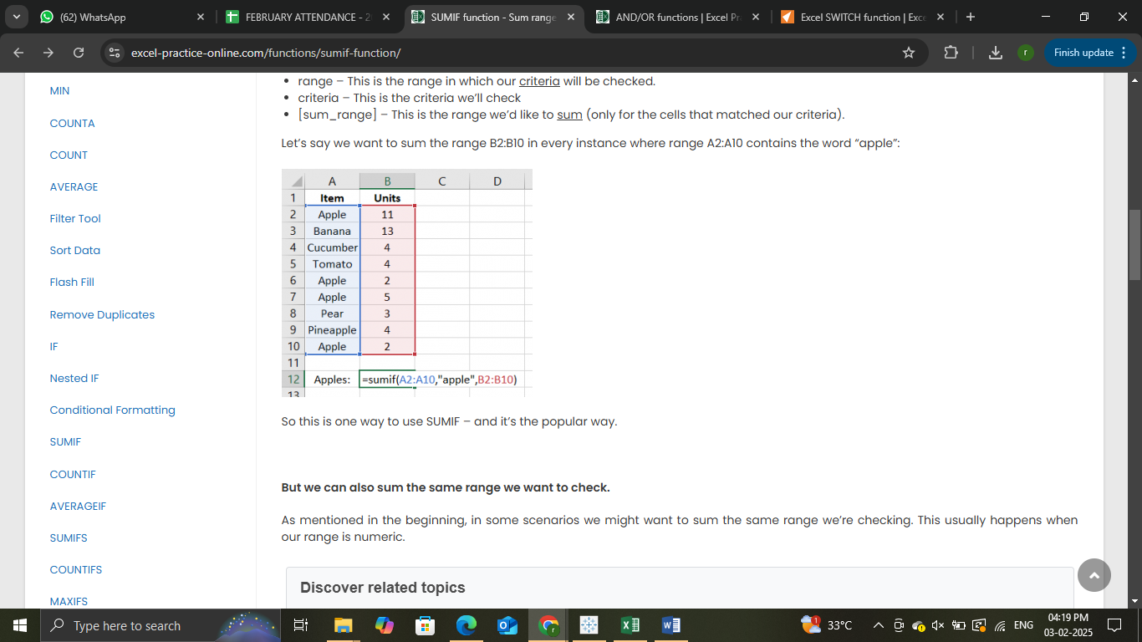

SUMIFS
SUMIFS function allows us to sum values that meet more than one criteria.
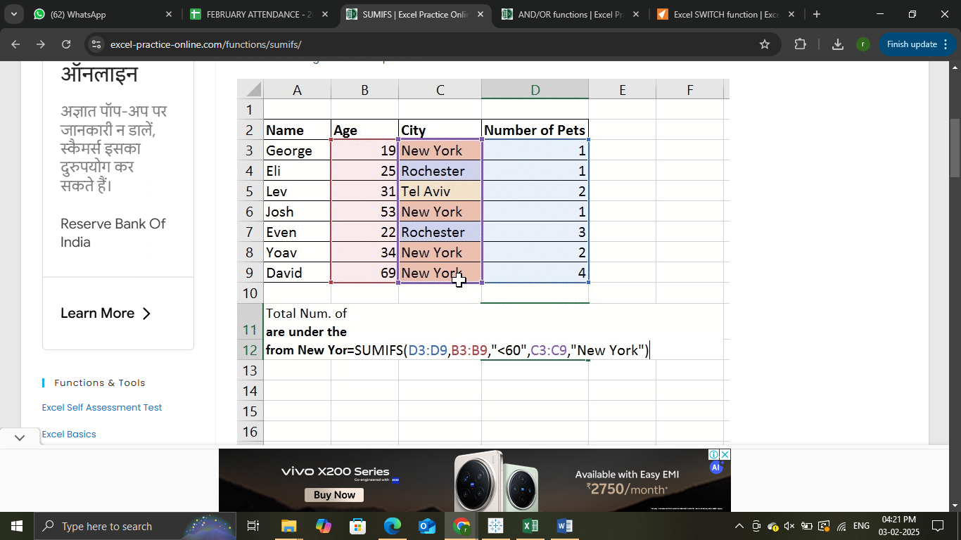

AVERAGEIF
AVERAGEIF function lets us calculate the average of a range based on certain criteria.
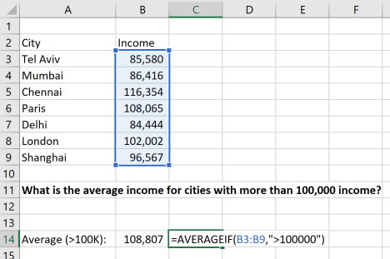

AVERAGEIFS
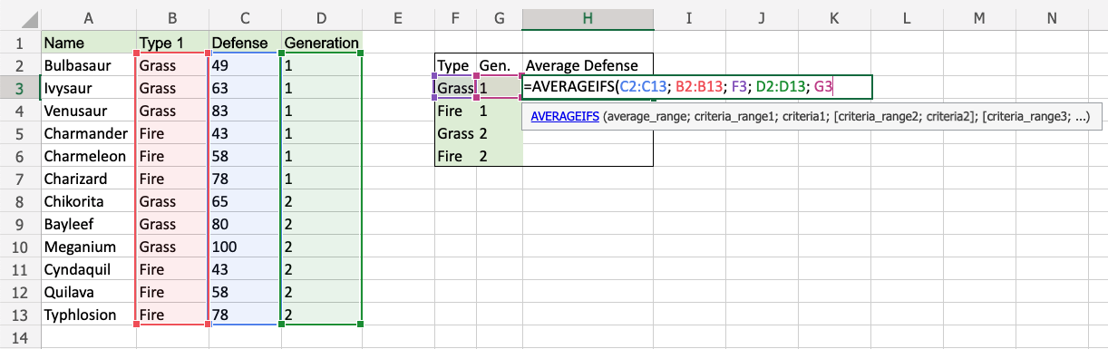

COUNTIF
It is a function that helps us count the number of cells within a specific range which meet a certain criteria.
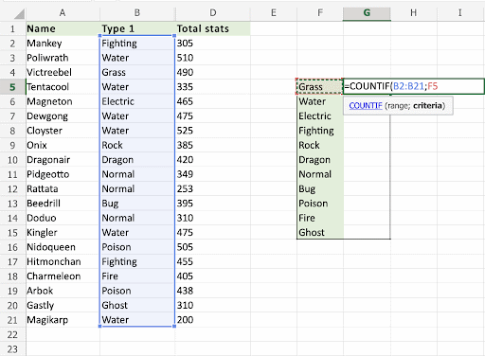

COUNTIFS
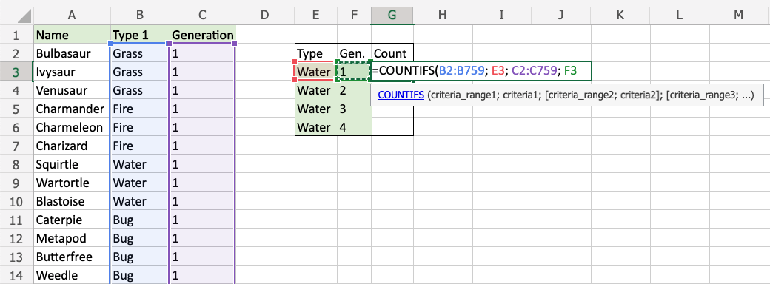

MAXIFS
MAXIFS function lets us find the maximum value in a range based on criteria.
MAXIFS allows the user to check multiple conditions in multiple ranges at once.
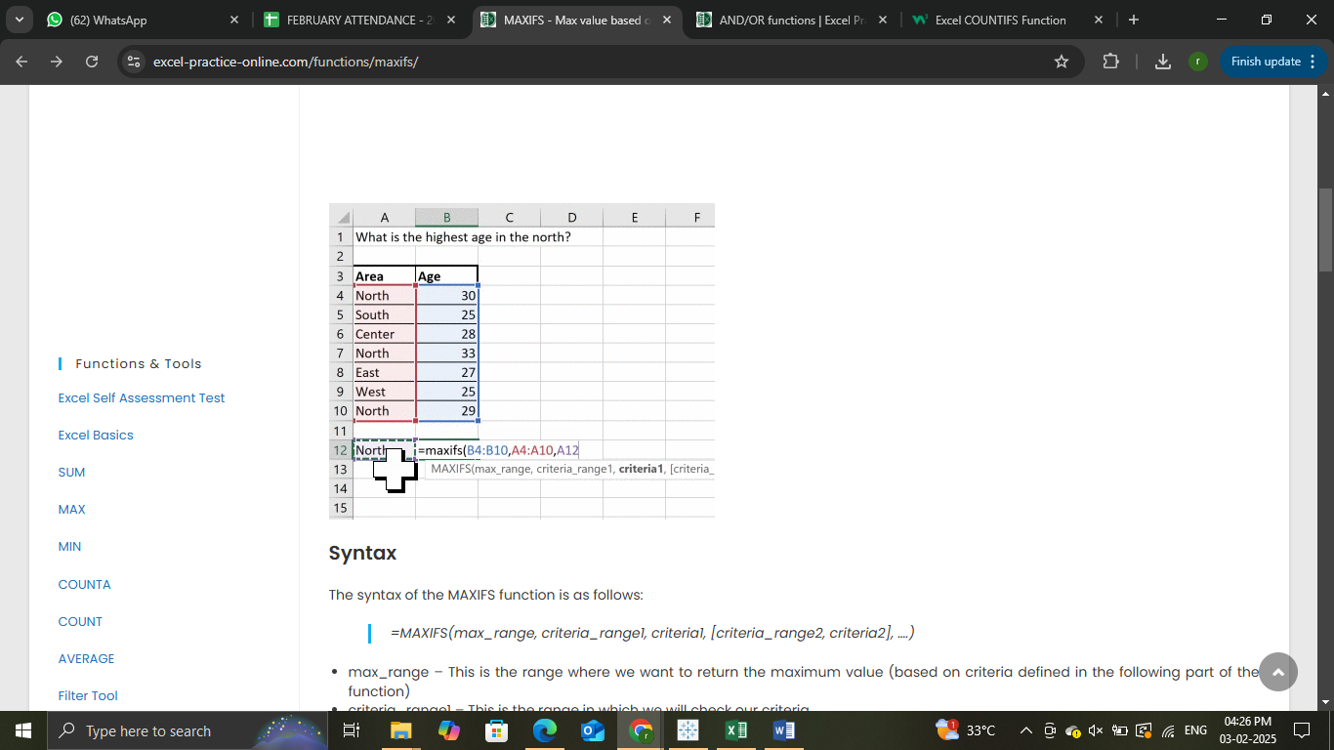

MINIFS
MINIFS function lets us find the minimum value in a range based on criteria.
MINIFS allows the user to check multiple conditions in multiple ranges at once.
